The Paper title (style "PAPER TITLE")
empty line
Name surname, Name surname, Name surname
empty line
Abstract: Use style "Abstract". Abstract in Czech. Abstract in Czech. Abstract in Czech. Abstract in Czech. Abstract in Czech. Abstract in Czech. Abstract in Czech. Abstract in Czech. Abstract in Czech. Abstract in Czech. Abstract in Czech. Abstract in Czech. Abstract in Czech. Abstract in Czech. Abstract in Czech. Abstract in Czech. Abstract in Czech. Abstract in Czech.
empty line
Keywords: comma separated keywords in Czech, comma separated keywords in Czech, comma separated keywords in Czech, comma separated keywords in Czech
empty line
empty line

The Paper Title in English

(style "PAPER TITLE")
empty line
empty line
Abstract: Use style "Abstract". Abstract in English. Abstract in English. Abstract in English. Abstract in English. Abstract in English. Abstract in English. Abstract in English. Abstract in English. Abstract in English. Abstract in English. Abstract in English. Abstract in English. Abstract in English. Abstract in English. Abstract in English. Abstract in English.
empty line
Key words: comma separated keywords in English, comma separated keywords in English, comma separated keywords in English
empty line
empty line
Use style "New paragraph". Skip two lines and start with the introduction (without the title). E.g. Lifelong Learning journal is an independent reviewed scientific and technical periodical, which publishes original scientific papers of Czech and foreign authors, scoping studies, outstanding student papers, reports and analytical reviews related to aspects of lifelong learning (especially vocational, further vocational training and education of the elderly).
For writing the bullets use style "bullets":
- First bullet
- Second bullet
- Third bullet
- Further bullets
empty line
1. Goals of the Paper (use style "Title")
Use style "New paragraph". Scientific articles based on your own research, theoretical studies and outstanding student papers have to include a formulation of the goal of the paper. The goals of the paper can be introduced in a separate chapter or they can be presented as a part of the introduction
empty line
2. Research Survey Methodology (use style "Title")

Use style "New paragraph". The papers presenting your own research and its results must contain, among others, the research goals and a brief description of the methodology used.
For a quantitatively oriented research, the description of the methodology usually contains hypothesis formulation, description of the research group, research methods, ways of data processing etc.
For a qualitatively oriented research, the description of the methodology usually contains research questions, qualitative research design (e.g. the grounded theory, case study, ethnography etc.), case selection (people, location etc.), methods of data collection, used analytical procedures etc.
empty line
3. Results and Discussion (use style "Title")
Use style "New paragraph". In this part of the paper the results of the scientific research themselves and their discussion are presented. The text is divided into chapters according to the author's intentions. Therefore the chapters don't have to be necessarily called "Results and Discussion".
Pay attention to the table descriptions. The title should be always provided above the table and the source should be placed below it. The table should be aligned left. Between the paragraph and the table title and also between the table and the following paragraph two lines should always be skipped. For the table formatting use the table style Light shading (in MS Word select the inserted table using right-click and in the menu choose: Design - Table style - Light shading). See the example below (Figure 1).
empty line
empty line
Figure 1
Compatibility of job personality and work environment types (style "Table and figure title")
empty line
Personality type | The most suitable work environment type | Other possible work environment types | Unsuitable work environment
R | R | I + C | S
I | I | R + A | E
A | A | I + S | C
S | S | A + E | R
E | E | S + C | I
C | C | E + R | A

empty line
Source: Mezera (2002, 9. 20)
empty line
empty line
Pay also attention to description of the figures and graphs. The title and source are always provided below the figure or the graph. The figure should be aligned left. Between the previous paragraph and the figure and between the title (source) of the figure and the following paragraph always skip two lines. See the example below (Fig. 1).

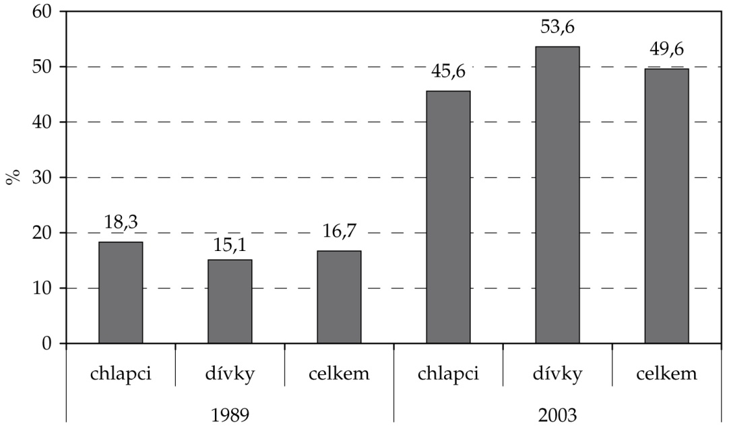
empty line
Figure 1. University aspirations among the pupils in the last year of primary schools between the years 1989 and 2003.
Source: Matějů, Smith, & Basl (2008, p. 384)
empty line
empty line
Conclusion (use style "Title")
Use style "New paragraph". This paragraph is devoted to the conclusion of the paper. After the conclusion, the Reference list section follows. In the reference list section you provide only the sources which are actually cited in the text and which the text refers to! Please, before sending the manuscript to the editorial office, check thoroughly that all the cited sources are mentioned in the reference list and vice versa. For formatting of the reference list use the style "Reference list".
For the journal articles, which have a DOI identifier, it also has to be provided in the reference list (see example for the journal article).
Standards for citing monographs, journal articles, chapters of books and electronic sources are provided below. For crediting the authors use first author-date system. E.g. According to Bělohlávek (1996) it is..., as Brown (2003, p. 139) states "career is..." etc.
empty line
Reference List (use style "Title")
Single author monograph (delete)
Eis, Z. (1994). Krize všedního dne: poznání, řešení, prevence. Praha: Grada.
Tamášová, V. (2007). Teória a prax rodinnej edukácie. Ivanka pri Dunaji: Axima.
Flanders, N. A. (1970). Analyzing Teacher Behavior. Reading: Addison-Wesley.
Two or three authors monograph
Novák, T., & Průchová, B. (2007). Předrozvodové a rozvodové poradenství. Praha: Grada.
Golombok, S., & Fivush, R. (1994). Gender Development. Cambridge: Cambridge University Press.
Zounek, J., Šimáně, M., & Knotová, D. (2017). Normální život v nenormální době: základní školy a jejich učitelé (nejen) v období normalizace. Praha: Wolters Kluwer.
More than three authors monograph
Čížková, J., et al. (1999). Přehled vývojové psychologie. Olomouc: Univerzita Palackého.
Hořánková, V., et al. (1995). Metodická příručka poradce pro volbu povolání. Praha: Sociologické nakladatelství.
Article or chapter in a book or proceedings (delete)
Švaříček, R. (2007). Hloubkový rozhovor. In Švaříček, R., & Šeďová, K., et al., Kvalitativní výzkum v pedagogických vědách (s. 159–184). Praha: Portál.
Jones, M., Dindia, K., & Tye, S. (2006). Sex Equality in the Classroom: Do Female Students Lose the Battle for Teacher Attention? In Gayle, B. M. (Ed.), Classroom Communication and Instructional Processes: Advances through Meta-analysis (s. 185–209). Manhay: Lawrence Erlbaum Associates, Publishers.
Articles in periodicals (delete)
Matějů, P., & Řeháková, B. (1992). Úloha mentálních schopností a sociálního původu ve formování vzdělanostních aspirací. Sociologický časopis, 28(5), 613–635.
Carroll, S., & Walford, G. (1997). Parents’ Responses to the School Quasi-Market. Research Papers in Education, 12(1), 3–26. https://doi.org/10.1080/0267152970120102
Kahle, J. B., et al. (1993). Gender Differences in Science Education: Building a Model. Educational Psychologist, 28(4), 379–404. https://doi.org/10.1207/s15326985ep2804_6
Knecht, P. (2014). Příležitosti k učení: odlišná/různá pojetí konceptu a jeho výzkumné využití. Pedagogická orientace, 24(2), 163–184. https://doi.org/10.5817/PedOr2014-2-163
Thesis (delete)
Šimáně, M. (2017). České menšinové školství v Československé republice: ke každodennosti obecných škol v politickém okresu Ústí nad Labem (Disertační práce). Dostupné z: https://is.muni.cz/auth/th/108981/ff_d/Finalni_verze_s_prilohami.pdf
Web page (delete)
Hlaďo, P. (2009). Volba povolání. Dostupné z: http://www.vychova-vzdelavani.cz
Mendelu, škola jako lusk: informace o univerzitě. (2010). Available from: http://www.mendelu.cz/cz/o_univerzite
Electronic book or proceedings (in the parentheses the type of the carrier is stated, e.g. CD-ROM, DVD etc.) (delete)
Linhartová, D., Máchal, P., & Danielová, L. (Eds.). (2010). ICOLLE 2010: Sborník příspěvků z mezinárodní konference [CD-ROM]. Brno: Konvoj.
Electronic document (e.g. Word, PDF, PPT) (delete)
Výzkum služeb kariérového poradenství a potřeb jeho klientů na základních a středních školách v ČR: souhrnná zpráva. (2003). Available from: http://www.vychova-vzdelavani.cz/files/dokumenty/download/zprava.pdf
Article from an on-line periodical (delete)
Lukášová, H. (2017). Učitelské sebepojetí – podněty k auto-evaluaci a výzkumu. ePedagogium, (1), 46–58. Available from:
http://old.pdf.upol.cz/fileadmin/user_upload/PdF/e-pedagogium/2017/e-Pedagogium_1-2017online.pdf

Author/Authors
Name and surname (with the academic titles), University, Faculty, Department, Street and house number, post code and town, e-mail: xxx@yyy.cz
Notes concerning the in-text references:
- Author and year of publication of the cited source is provided directly in the text, the format is name, year in parentheses (Zounek, 2013). In case that the text has two or more authors, their names are connected using ampersand (Koťa & Strouhal, 2017; Zounek, Šimáně, & Knotová, 2017). When referring to more sources, all of them are mentioned in the parentheses in the alphabet order and separated by a semicolon (Le Goff, 1981; Stone, 1979; Zounek, Šimáně, & Knotová, 2017). Pages, where the citations are located, are mentioned in the parentheses, directly after the year, separated by a comma (Kasper, 2007, p. 103).
- In case that there are more sources published by the same author in the same year, they are distinguished by a lowercase letter added to the year of publication (Rýdl, 2010a). The letters are then also provided in the final reference list.
- If the author's name appears in the text naturally, you only add the year in the parentheses: Skalková (1995), eventually with the location: Skalková (1995, p. 120).
- The names of the female authors are declined only in the text, in the parentheses and in the reference list they remain in the original form.
- Shorter citations (up to three lines) from the bibliography or other sources are in the main text marked by quotation marks. Citations longer than three lines are written in 10pt size and separated from the rest of the text by one empty line before and after the text of the citation. Quoted text is not marked by quotation marks, see the following example:
…from the definition in the German dictionary Meyers kleines Lexikon – Pädagogik (Průcha, 2005), where the school is described as:
institution in the public or private property, in which knowledge and skills are transmitted to children and youth through systematic education, that should enable them independent life activities within the state and social order. The schools usually provide it within the certain amount of time, they are located in the same place, independently to the changes of pupils and teachers, and they are oriented towards the relevant forms of education and training. They strive to achieve defined goals of education and training (p. 398).
The school is therefore understood as an institution, where the education and training are the key processes. Pol (2009) in this context points out that from the institutional point of view, all the schools are equally connected to the unified external frame, which is, in many respects, biding for them. According to this author, the school is: "strongly related to the wider social context - its operation is significantly determined by the traditions, national and global culture, ..." (p. 12).

